

Steps To Create Functional Location

Document Control

Prepared by:
Version | Date | Name
1.0 | 01/20/2025 | SHANTANU DESHMUKH
2.0

Reviewed by:
Version | Date | Name
1.0 | 01/28/2025 | NIKHIL KOOLWAL, SRINIVAS RAO PATHI, VIJAY PATIL

Reference Documents

The following section describes relevant documentation:

Document Name | Description | Sharepoint Link
Create Functional Location | How To create a Functional Location | Functional Location Doc

Contents
1.What is Functional Location 4
1.1 Steps to create Functional Location 4

1.2 Steps to create Equipment 5
2.Functional Location Hierarchy 12
2.1 Create or Assign a Superior Location 12

1.What is Functional Location

A Functional Location in SAP is a hierarchical structure used in Plant Maintenance to represent a physical location where maintenance tasks are performed, such as a plant, building, or equipment area. It helps in organizing, planning, and tracking maintenance activities systematically.
- Structure refers to the arrangement of functional locations and equipment based on technical, spatial, or functional criteria. It represents the organization of assets in a logical order (e.g., plant > department > machine).
- Hierarchy defines the levels of this arrangement, showing relationships between parent (superior) and child (subordinate) elements, enabling efficient maintenance planning and tracking.
- For example:
Plant > Building > Floor > Equipment > Sub-equipment.

1.1Steps to create Functional Location

Login to SAP Fiori - https://awsast0685.enggsap.accenture.com:44300/sap/bc/ui2/flp?sap-client=100&sap-language=EN
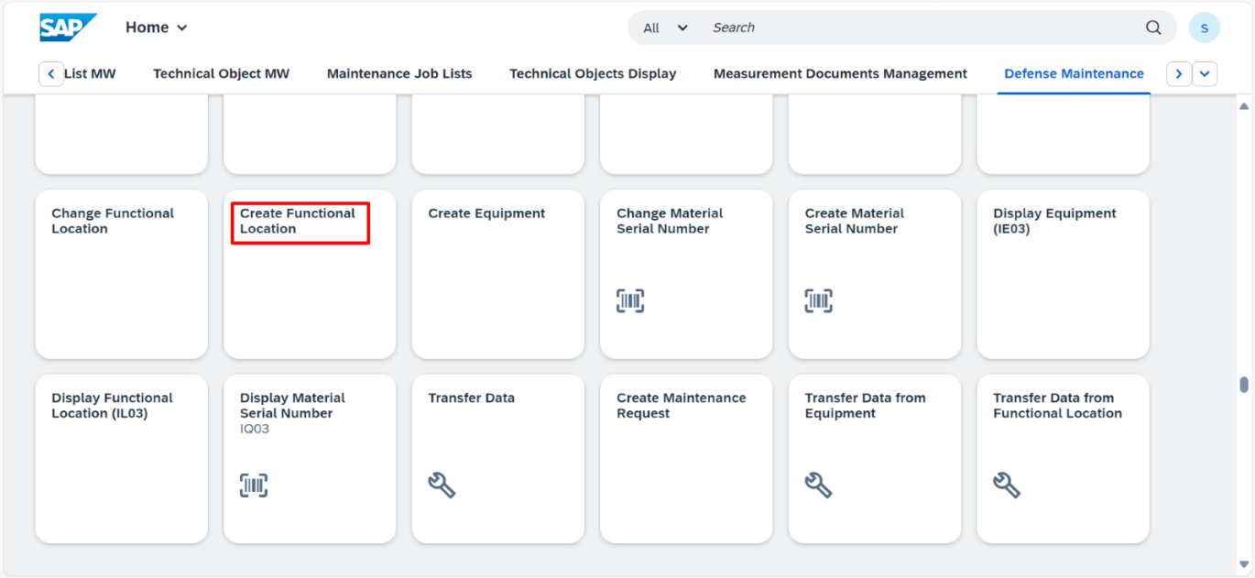
Fiori dashboard is displayed and then click on create Functional location.

Functional location Initial screen is displayed as shown below.

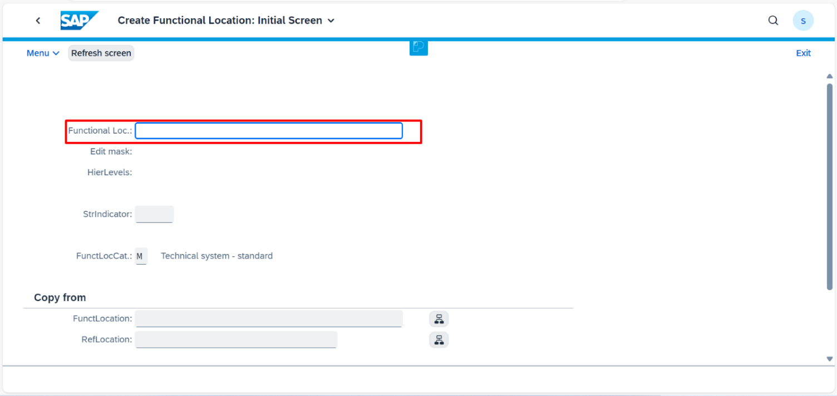
1.2 Steps to create Equipment

Equipment can also be created through SAP GUI.
Below are the steps:
1.In Sap GUI enter the T-code IL01
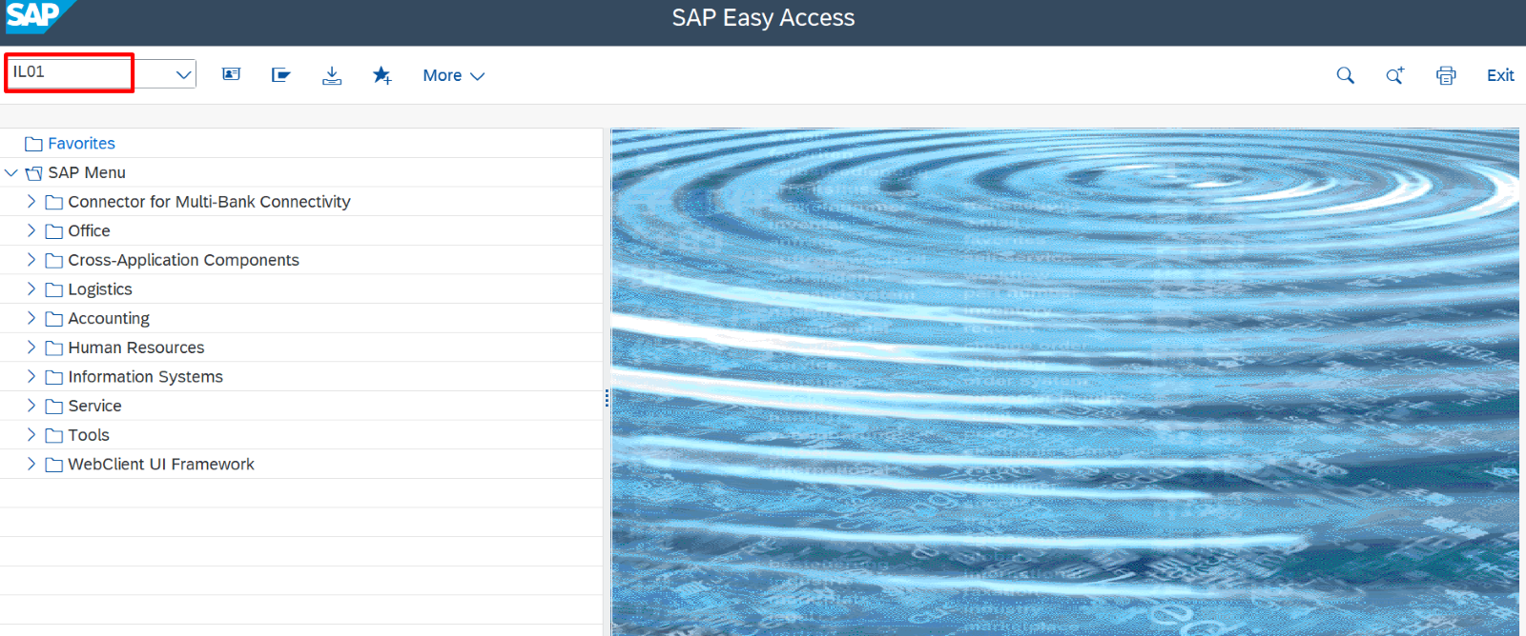
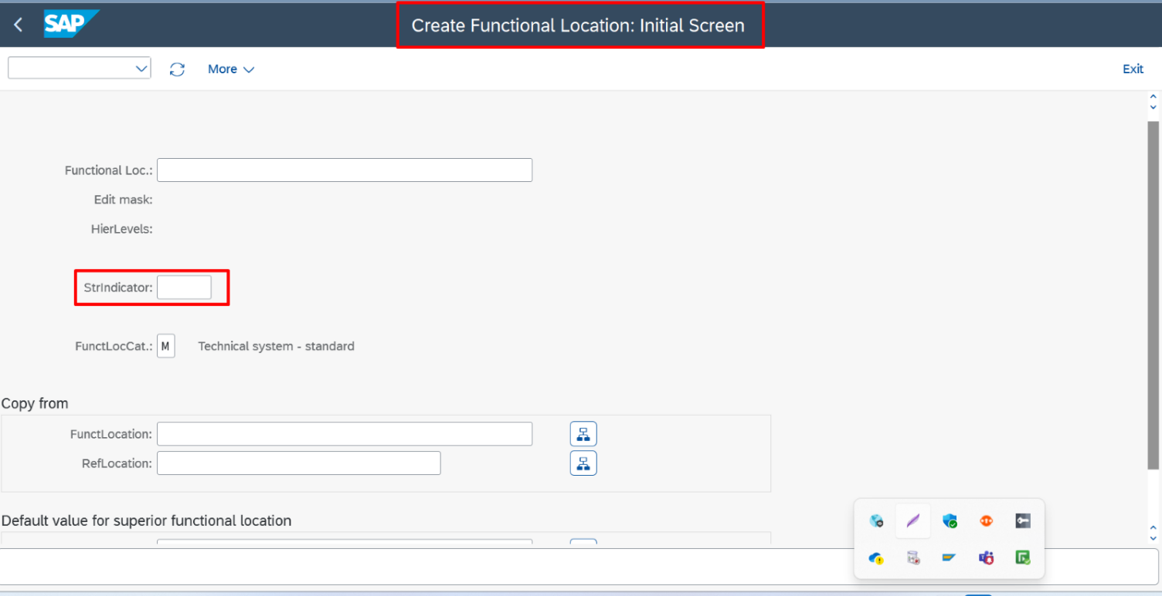
2.The screen Create Functional Location: Initial is displayed.

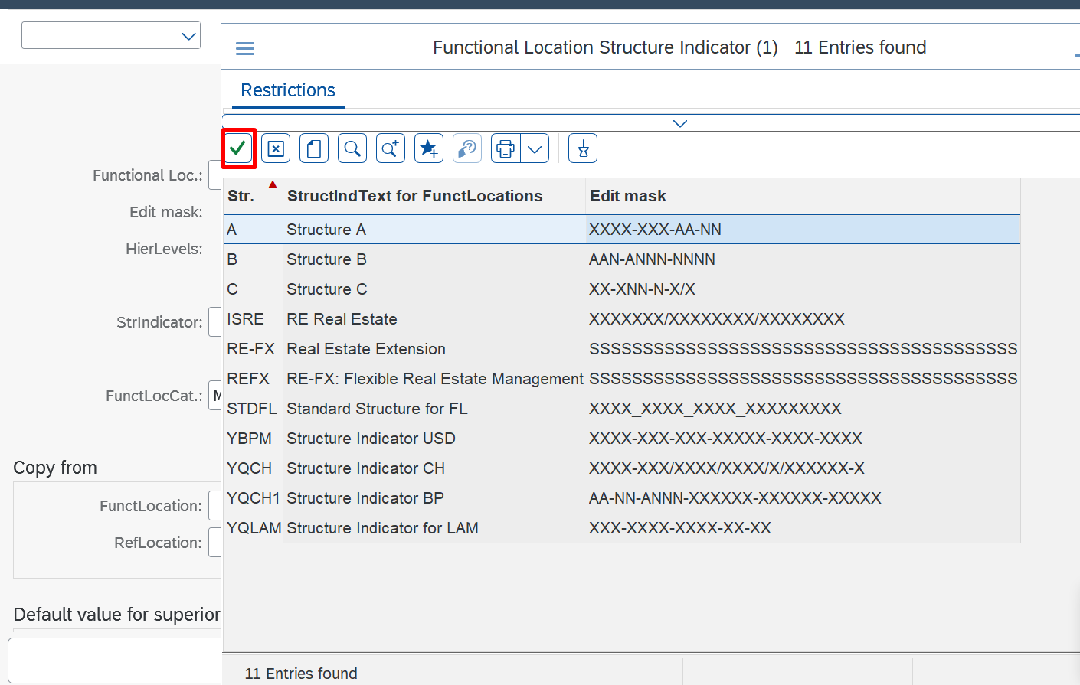
3. Enter the structure indicator you require and choose Continue.
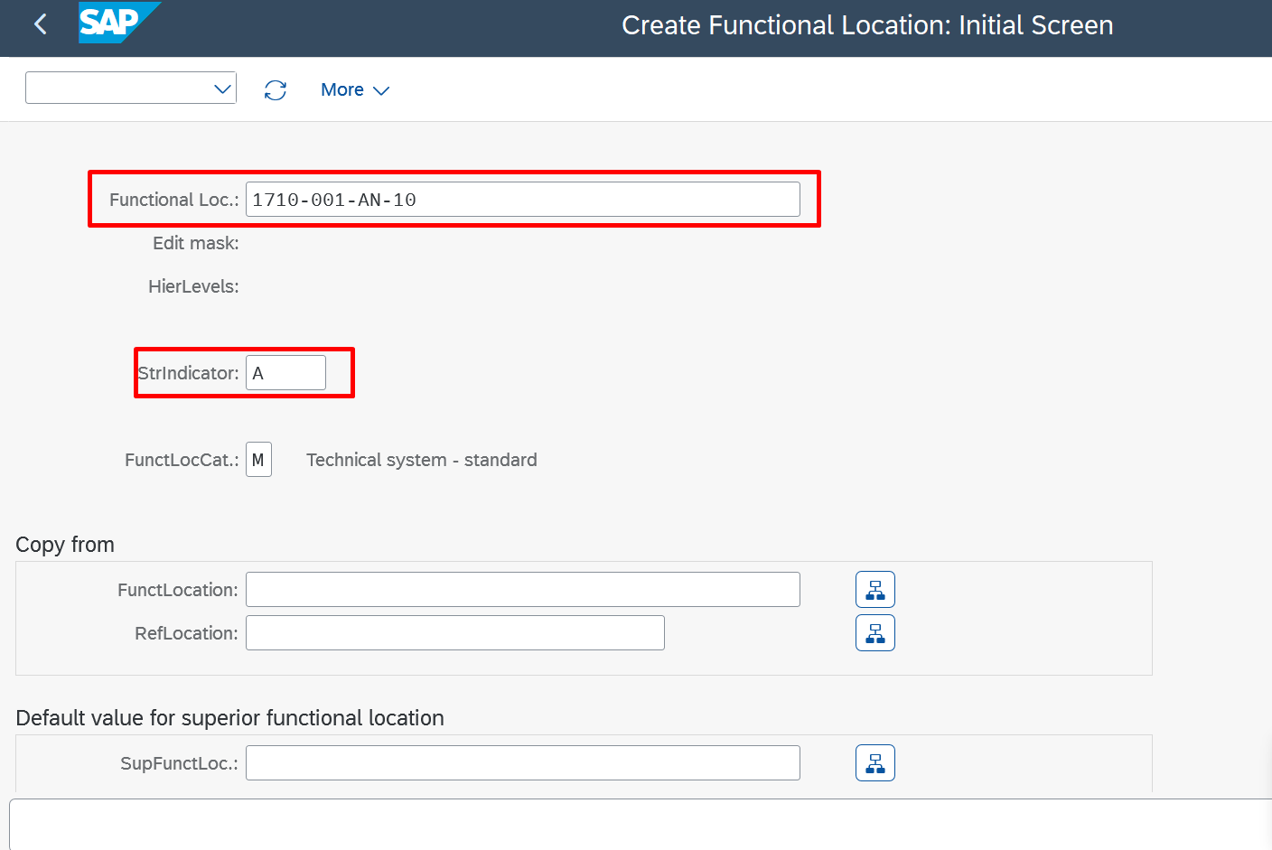
4. Enter the functional location label and a technical location as a reference if necessary and choose Continue.

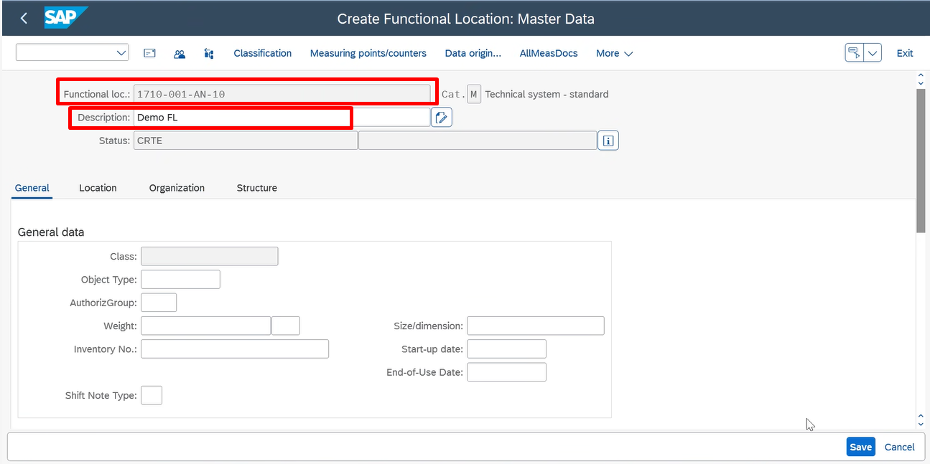
5. Press Enter and enter Description.

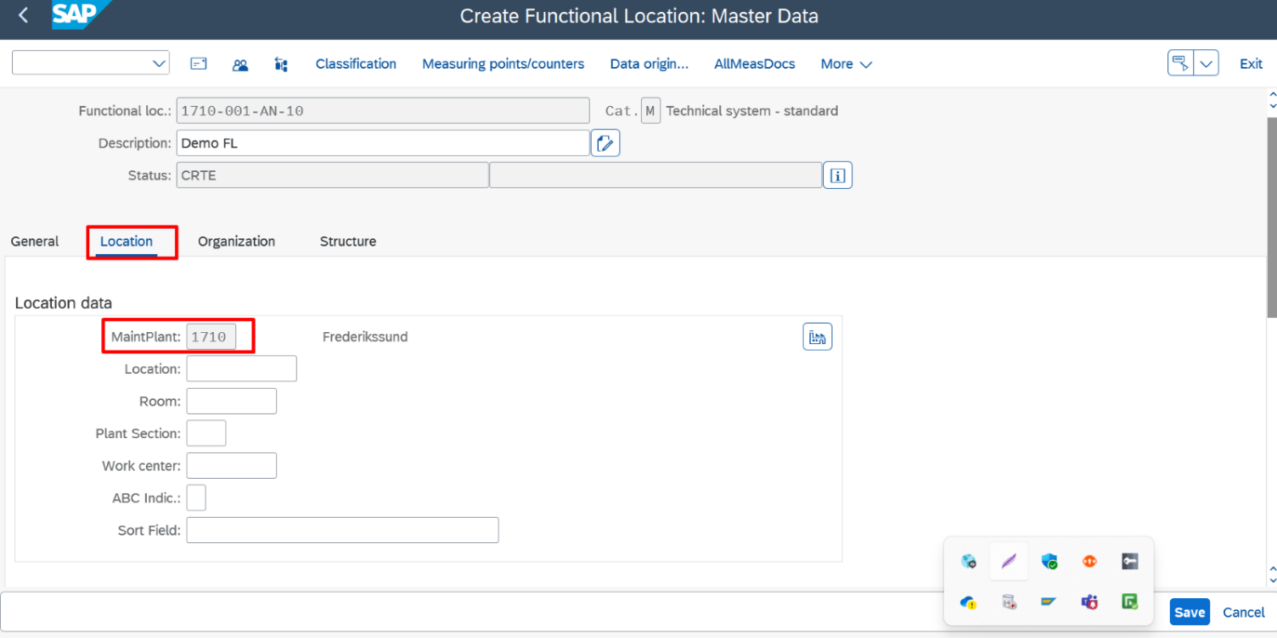
6. In location tab, enter the maintenance plant and make all the necessary entries if required.

7. If you want to classify the functional location, choose Go to Classification. You go to the classification processing function.
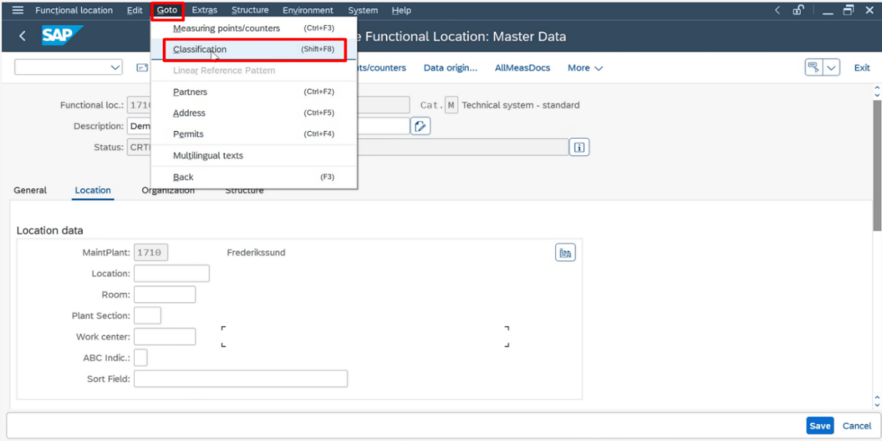

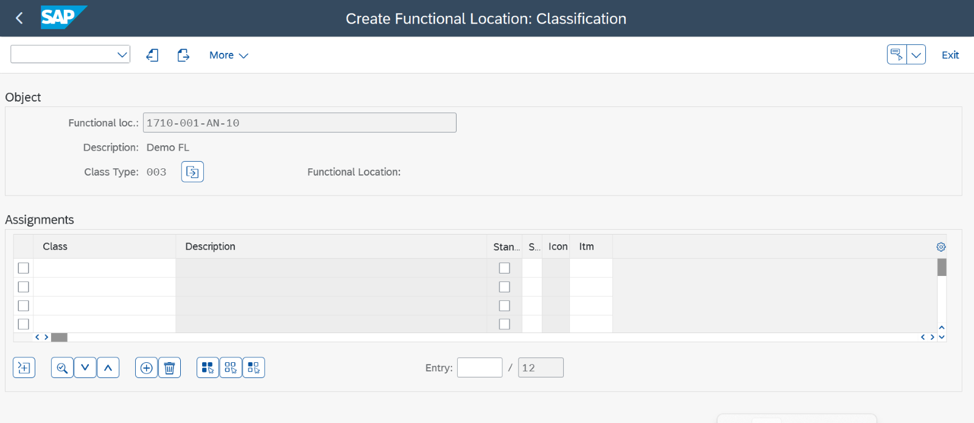

8. Save the master record.
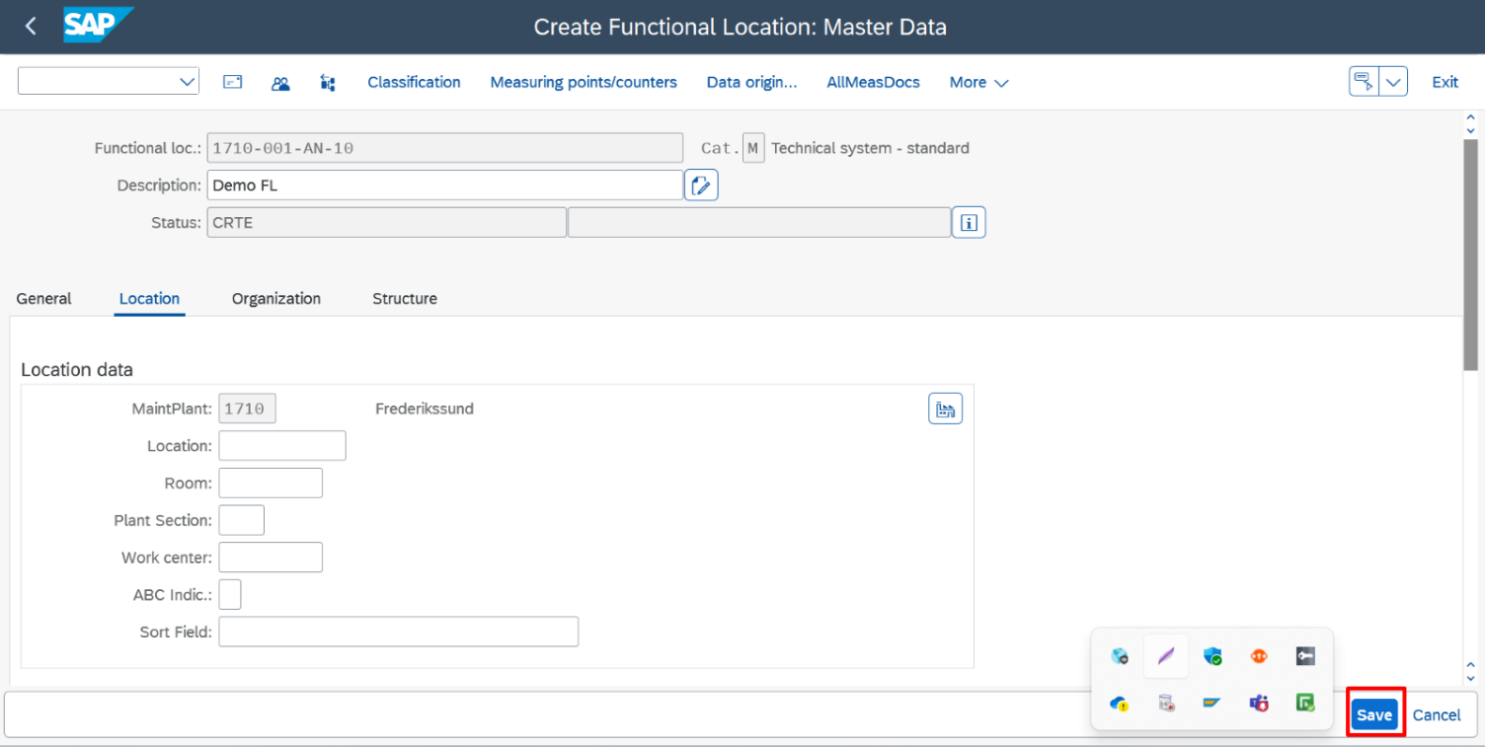

9. Functional location is created.
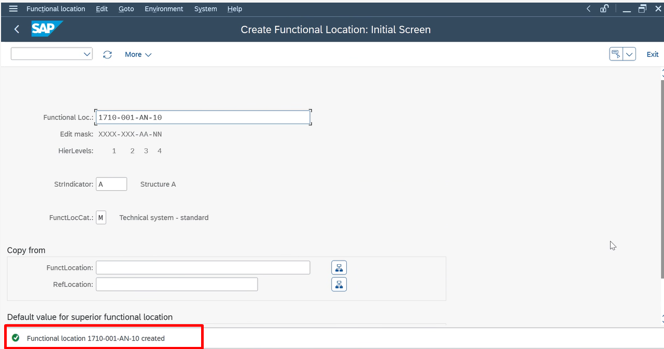

2.Functional Location Hierarchy

A functional location hierarchy in SAP is a structured representation of physical, technical, or organizational units within a plant or facility.
It helps organizations manage maintenance, repairs, and technical data by organizing these units into parent-child relationships.
The hierarchy reflects the actual setup of equipment and facilities, making it easier to locate, plan, and maintain technical objects. Functional locations are identified using unique IDs and structured in levels based on logical or physical connections.

2.1 Create or Assign a Superior Location

1.Open IL02 (Change Functional Location) for the child location.

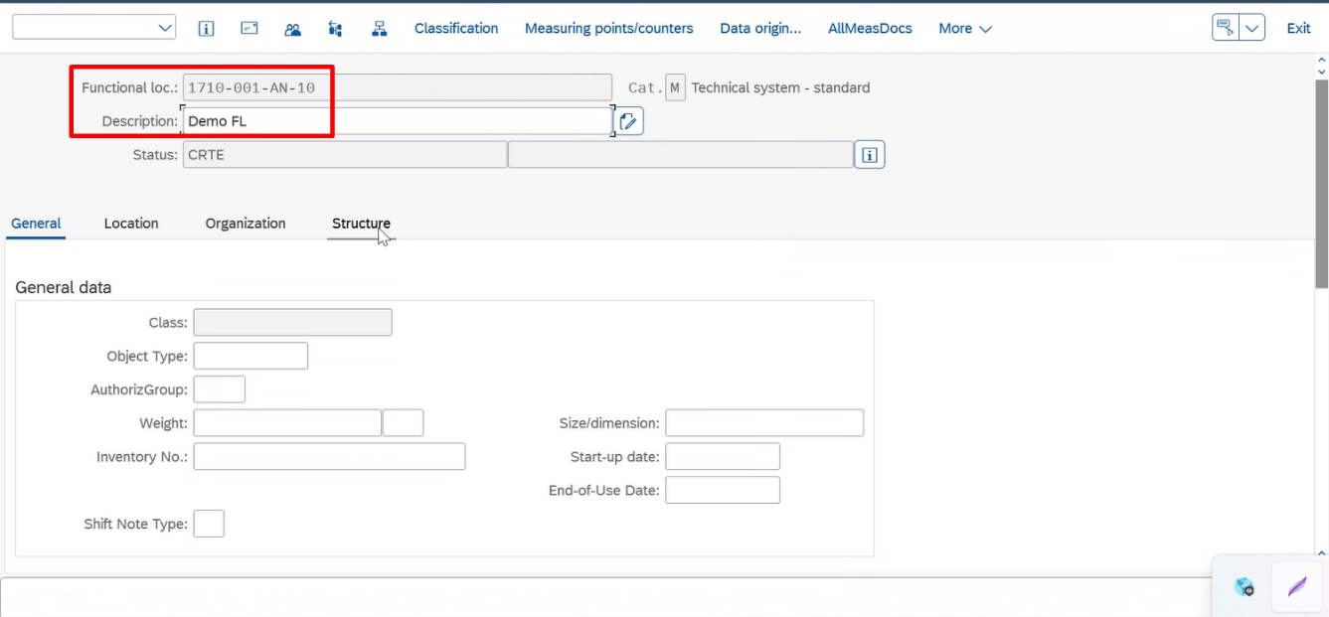

2.Navigate to the Structure tab. Enter the Superior Functional Location (parent location) under which this location will be structured.

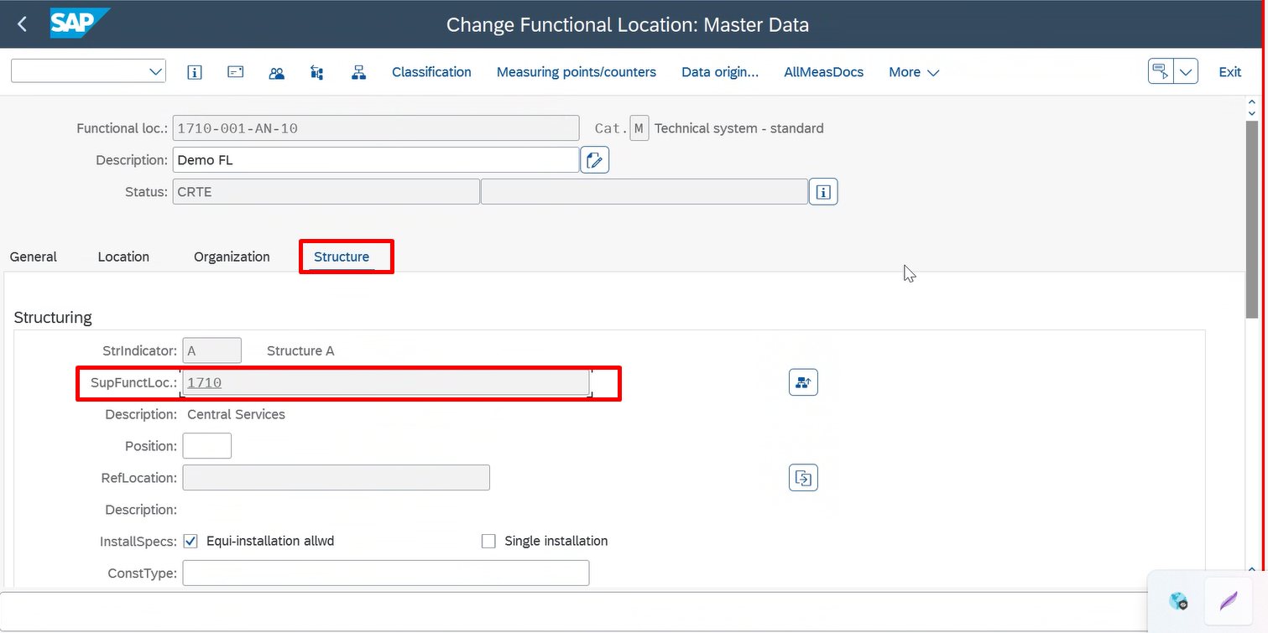

3.Save the changes.

